Digital Chip Design Program
RTL Design
Alia Alsultan
Aryam Alharbi
Elat Alkhalaf
Lana Aldhali
Manar Alnuqaydan

Task #01
29/06/2026
Gate-level

Task #1.1
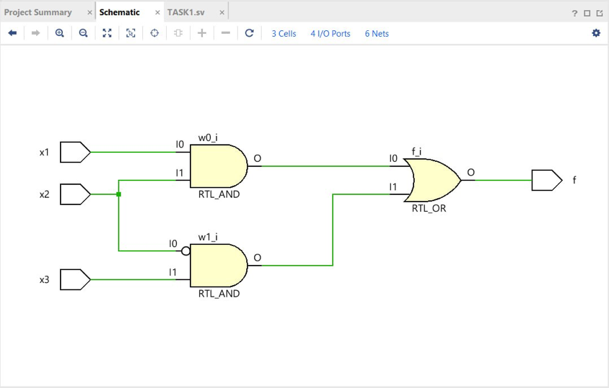

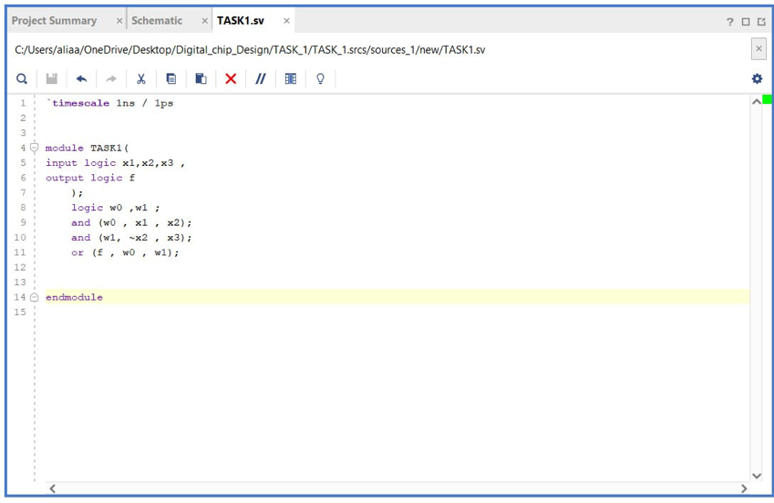

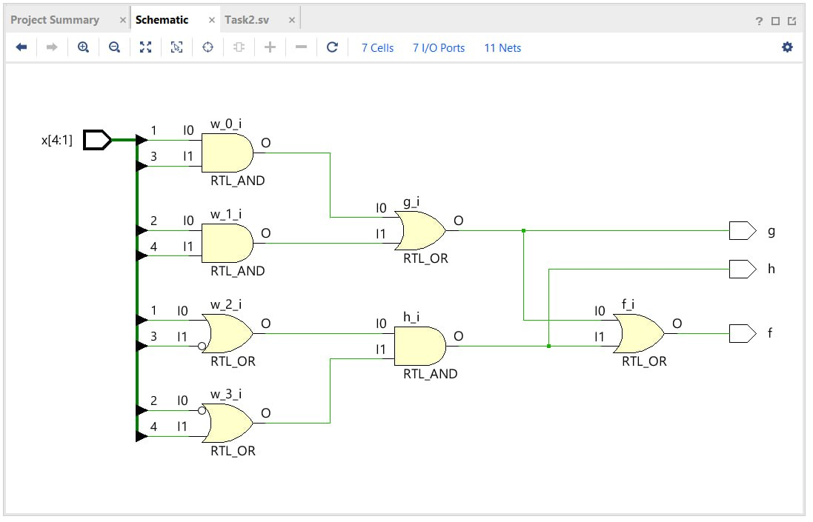
Task #1.2
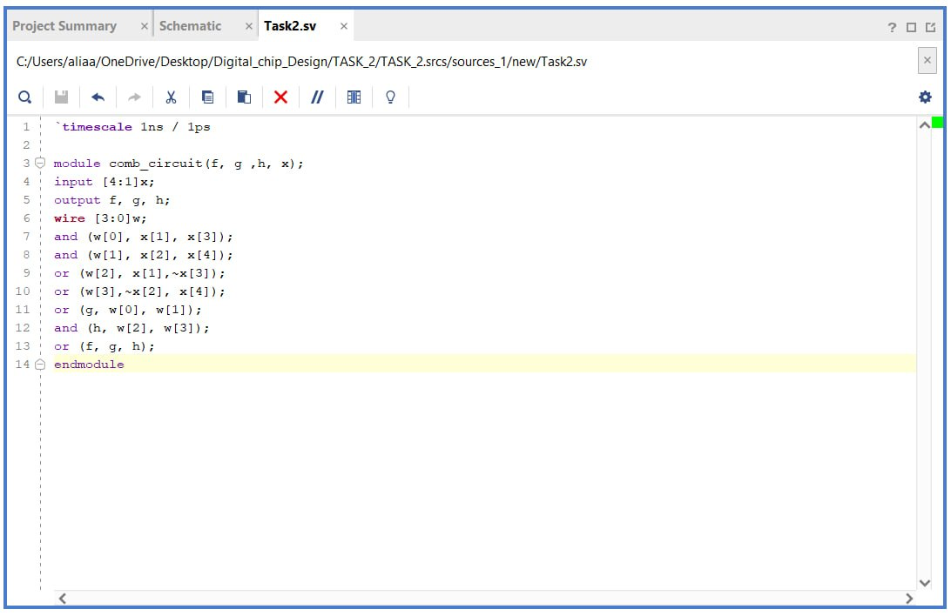

Task #1.3
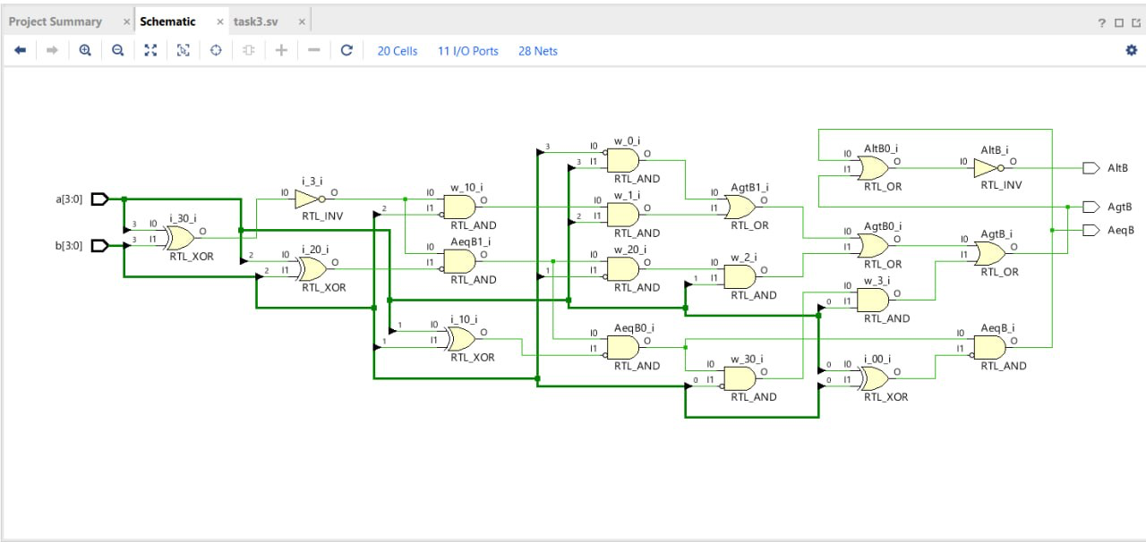
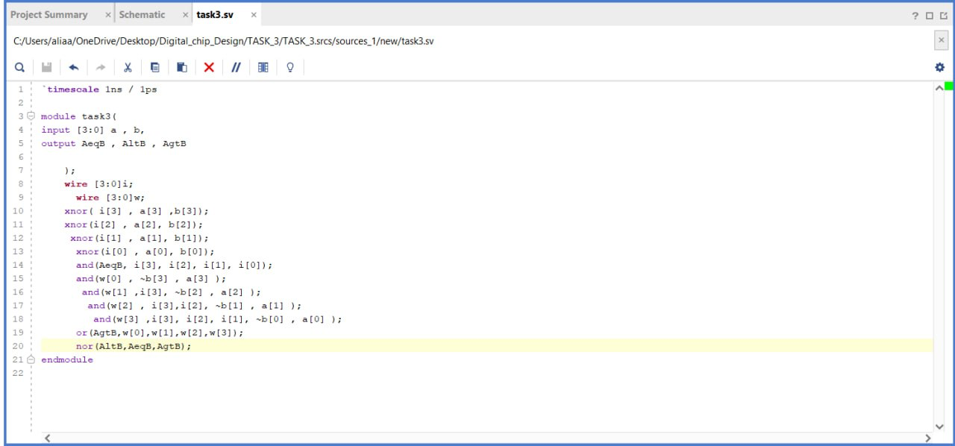

Work distribution

Section | Alia | Aryam | Elaf | Lana | Manar
Report | ✔ | ✔ | ✔ | ✔ | ✔
Task n.x | ✔ | ✔ | ✔ | ✔ | ✔
Task n.x+1 | ✔ | ✔ | ✔ | ✔ | ✔
Task | ✔ | ✔ | ✔ | ✔ | ✔

